Recycle Old Halloween Costumes!
Donate a new or gently used Halloween costume to ‘Ween Dream, a nonprofit that gives free Halloween costumes to children in need across America!

We accept Halloween costumes in all sizes
Please drop off all donations in the elementary school. There will be a bin for collections.
Thank you, have a great Halloween!
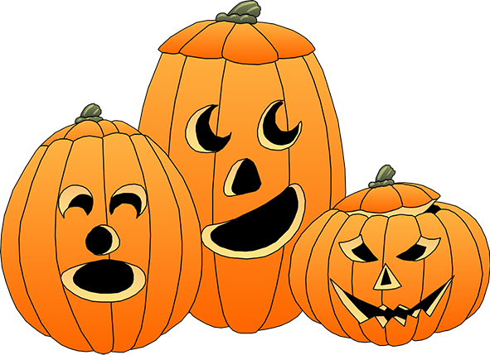
For any questions/concerns please contact:
190830@whrhs-stu.org
For Halloween 2015, ‘Ween Dream gave costumes to approximately 1,200 children in 24 states!

